OFFICIAL COORDINATION REQUEST FOR
NON-ROUTINE OPERATIONS AND MAINTENANCE

COORDINATION DATE- 10 January 2010
PROJECT- Bonneville Lock and Dam
RESPONSE DATE- 13 January 2010 (FPOM meeting)

Description of the problem- The Corps (Sean Tackley is POC), NOAA Fisheries (Mary Moser), and the University of Idaho (Chris Caudill) are proposing installation of mounting structures for DIDSON or similar acoustic imaging devices for a 2011 lamprey study at two locations:

- Bonneville Washington Shore North Downstream Entrance (NDE). The guide would be attached to the Lamprey Passage System (LPS) structure downstream of the NDE (Figure 1). Below the surface, the guide and DIDSON combination would be no wider than the existing structure, and the guide would extend below the existing structure. During the lamprey passage season, a DIDSON would be mounted to the guide and lowered down for the evaluation of adult lamprey at and around the entrance. The DIDSON would be operated periodically at this entrance throughout the lamprey passage season (approx. June 1 – October 1).

- Cascades Island Fish Ladder Entrance. An i-beam/rail would be installed inside the fishway entrance area, along the inside of the south wall (Figure 2). The diagonally-mounted beam would approximately mirror the LPS on the opposite wall, and would be used to monitor fine-scale lamprey behavior in proximity to the bollard array and LPS. During the lamprey passage season, a DIDSON mounted to a trolley would be lowered down the guide/rail for the evaluation. The DIDSON would be operated at this entrance throughout the lamprey passage season (approx. June 1 – October 1). The I-beam will be similar to an existing ADD beam upstreamstream ~30’ (the ADD beam is too far upstream to provide imagery at the entrance). The guide rail will extend to 3-ft. above the fishway floor to provide an unobstructed path along the lower wall for passing lamprey.

Type of outage required- N/A

Impact on facility operation- None anticipated.

Length of time for repairs- Installation will occur during the 2010/2011 IWW period, while Washington Shore Fish Ladder and Cascades Island Fish Ladder are dewatered for maintenance. DIDSON equipment would be operated throughout the lamprey passage season (approx. June 1 – October 1).

Expected impacts on fish passage- No impacts on adult salmonid passage are expected as a result of installation of the DIDSON guides/rails or operation of the DIDSON units during the fish passage season. Both structures are adjacent to or inside fishway entrances, but the overall footprint and orientation of these structures and DIDSON devices should result in minimal to no disruption to normal fish passage behavior. If necessary, deployment can be limited to nighttime hours only, though this may preclude qualitative evaluations of salmon passage behavior in these areas.

Comments from agencies-
Thanks for clearing this up Sean. Now that we see the details, we have no problems with the I-beam installation in the Washington shore ladder. We'll look at the Cascade Island design once you get it put together. Gary

On 1/27/2011 3:25 PM, Tackley, Sean C NWP wrote:
> Dear FPOM Representatives and Interested Parties:
>
> I have a couple of updates regarding the attached coordination form.
>
> At the January FPOM meeting, FPOM reps requested additional details on the DIDSON rail designs to be deployed during the current IWW period. Attached you will find a 3-page (PDF) addendum to the coordination form. This document describes, in greater detail, the design of the i-beam and mounting brackets to be used for the Bonneville WA Shore DIDSON rail. These drawings, photo, and specs were reviewed and generally approved today at the Portland District FFDRWG meeting.
>
> Due to logistical constraints and crane/rigger availability, the Cascades Island DIDSON i-beam will not be installed this IWW period. Thus, you may ignore the request to install that structure. Our colleagues at the University of Idaho and the FFU are working on potential alternative solutions that will allow DIDSON deployment inside the Cascades Island entrance during the lamprey passage season. Should the team come up with an alternative design, I will be sure to route it by FPOM, FFDRWG, and our Tribal partners for review and approval.
>
> Please review the PDF file and provide comments to me and Tammy Mackey by COB Feb. 1. The tentative installation date for the WA Shore DIDSON rail is February 15, so we appreciate your prompt response!
>
> Best Regards,
> Sean
Final results- approved for Washington Shore.

Please email or call with questions or concerns:
Sean C. Tackley
503-808-4751
sean.c.tackley@usace.army.mil

Figure 1. Rough diagram of proposed Washington Shore NDE LPS guide for DIDSON device.

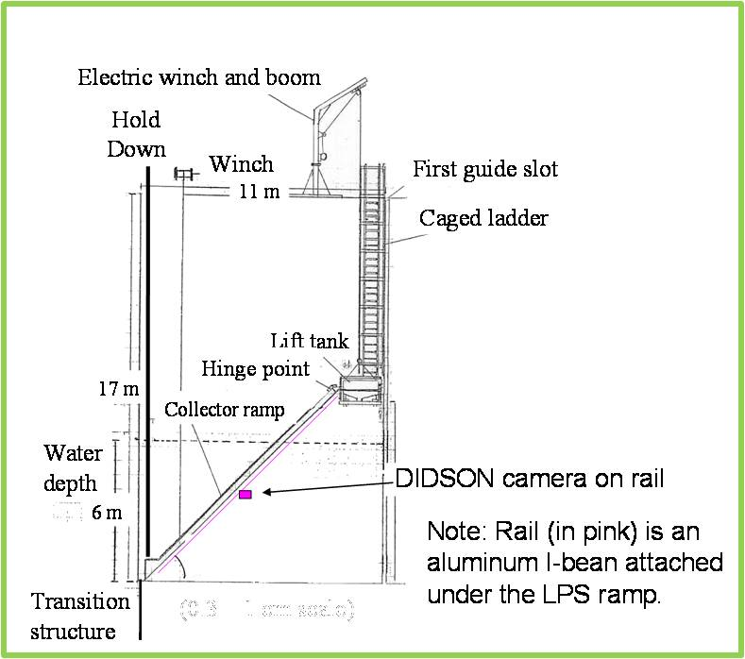

Figure 2. Location of proposed DIDSON guide/rail inside the Cascades Island entrance. The existing ADD I-beam is visible at the left margin of the photo.

